CS7646: Project 6 – Indicator Evaluation

Marcus Anderson  
manderson332@gatech.edu

***Abstract—***In this report, I developed technical indicators and a Theoretically Optimal Strategy algorithm that will also be utilized in a future project. The technical indicators will be used in the development of an intuition-based trading strategy and a Machine Learning-based trading strategy. Whereas the Theoretically Optimal Strategy algorithm will provide a benchmark for evaluating the performance of the later project. Even though, the expectation is that the Machine Learning-based trading strategy will outperform the intuition-based strategy, it’s not guaranteed.

**1 INTRODUCTION**

In this project, the focus is on two main components: indicators and optimal strategy. The first component involves researching and implementing five market indicators. These indicators will be utilized in the later project to generate trading signals for the intuition and Machine Learning based trading approaches. The goal of this component is to develop a clear understanding of various trading indicators and how they might be implemented to generate trading signals.

The second component involves the development of a theoretically optimal strategy, which represents the upper bounds or maximum amount that can be earned through trading given a specific instrument and timeframe. This strategy does not use any indicators but rather relies on other factors to determine its maximum earning potential.

By the end of this project, readers are expected to have a solid understanding of different trading indicators and how they can be implemented to generate trading signals. They should also develop an understanding of how the optimal strategy can be used to maximize earning potential through trading given a specific instrument and timeframe.

**2 TECHNICAL INDICATORS**

The first component of this project was to identify five market indicators to help develop an understanding various trading indictors and how they could be used to generate trading signals. The constraints used for these indicators are as follows: only use the JPM asset, the time period must be between January 1, 2008 to December 31, 2009, and starting cash is $100,000.

**2.1 Simple Moving Average (SMA)**

The Simple Moving Average (SMA) is a popular technical indicator in markets that calculates the average price of a security over a specified period. SMA is known as a lagging indicator, which means it measures the occurrence and frequency of past events, rather than future ones.

SMA is calculated by summing up the closing prices of a security for a specified number of periods, or days, divided by the total number of periods: **SMA = (Sum of closing prices for N periods) / N periods**.

SMA is a widely used technical indicator in trading and investment analysis. It is used to identify the direction of the trend and the potential areas of support and resistance. SMA makes is easier to view prices trends by smoothing out the volatility of an average security price over a specified period. If the price is above the SMA, it indicates that the security is increasing, while below the SMA indicates a decrease. The longer the moving average’s timeframe, the smoother the simple moving average will be overall.

Traders utilize SMA to generate buy and sell signals by comparing the current price of a security with its SMA. If the price is above the SMA line, it’s seen as a buy signal, while if it falls below the line, it’s a sell signal. A shorter-term SMA is more volatile to price changes and generates signals more frequently, while a longer SMA would be more stable, generating much fewer signals.

The figure shown below, Figure 1, shows the price movement of the JPM security as it relates to its 5-day SMA period. Using the SMA line, we can see what traders would use to single their buy and sell actions.

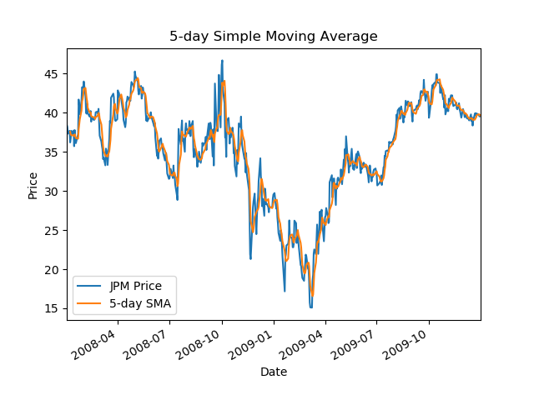

*Figure 1—This graph shows the relationship between the prices of JPM and a 5-day Simple Moving Average (SMA period.*

**2.2 Exponential Moving Average** **(EMA)**

The Exponential Moving Average (EMA) is a technical indicator used to smooth out the price data, and reduce lag, by giving more weight to the most recent price. Unlike SMA, EMA is dependent on the EMA calculations for all the days prior to the specified day. This makes EMA react more quickly to the recent price changes than SMA, and helps to identify price trends and potential reversals.

EMA is calculated by taking account of historical prices of a security during a certain period length, while also factoring in the multiplier element: **2 / (Time periods + 1)**. The full equation is: **EMA = (Close - EMA(previous day)) x Multiplier + EMA(previous day).** The first EMA value will be the SMA of the last period length’s closing prices. We can then use the formula to calculate the next day's EMA value. A bit more complicated than SMA I’d say!

As stated earlier, EMA is more responsive to the market changes than SMA, which can help traders to indicate when to buy and sell faster. EMA can also be coupled with other technical indicators to generate buy and sell signals. One of the most popular strategies is to use two EMA with different time periods, such as 50-day and 200-day EMA, which could deemed a medium/long term period. When the short-term 50-day EMA crosses over the 200-day long-term EMA, it’s considered a bullish crossover, while the short-term EMA crossing over the long-term EMA is considered a bearish crossover. These strategies are typically known as the Golden Cross and Death Cross, respectively. EMA can help lessen the negative impacts of a lagging indicator because it places more weight on the latest data, keeping itself closer to price movements. This can provide a sense of security when traders are looking for buying and selling opportunities when the price reacts off the EMA line.

Figure 2 showcases the price movement of the JPM security as it relates to a 10-day EMA period. As we can see, the 10-day EMA is more responsive to the price changes and hugs the price closely. We can use longer term EMA periods, like 50-day and 100-day, to help filter out short-term volatility and provide a better overall picture of the long-term trend.

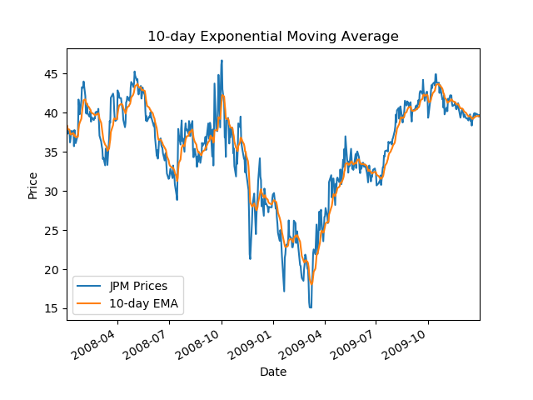

*Figure 2—This graph shows the relationship between the prices of JPM and a 10-day Exponential Moving Average (EMA) period.*

**2.3 %B Indicator (%B)**

The %B technical indicator is a technical indicator that measures the position of the current price relative to the upper and lower Bollinger Bands. Bollinger Bands (BB) is a technical indicator that’s used to identify the volatility and potential price movements of an asset. BBs consist of three lines: the upper band, lower band, and middle band, which is a simple moving average of the price. The %B indicator is more of a normalized version of the BBs that ranges from 0 to 1, indicating where the current price is relative to the upper and lower bands. This is typically how traders can identify overbought and oversold situations.

The formula for the %B indicator is: **%B = (Price - Lower Band) / (Upper Band - Lower Band)**. This means in order calculate the %B indicator, you must calculate theupper/lower bands from BB. As mentioned earlier, the middle band is the SMA over a period of 20 days. The upper band is calculated by adding the 20-day standard deviation multiplied by 2 to the middle band value: **Upper Band =** **Middle Band + (20-day standard deviation x 2**). The lower band is the same, but instead of adding the standard deviation factor multiplied by 2, you subtract it: **Lower Band = Middle Band – (20-day standard deviation x 2)**.

Traders use the %B indicator with other technical indicators to generate buy and sell signals. They can use a crossover of the %B indicator and the moving average of the %B indicator. This means when the %B indicator crosses above its moving average, it’s a buy signal, and when it crosses below, it’s a sell signal. Additionally, %B can also be used with Relative Strength Index (RSI) and Moving Average Convergence Divergence (MACD), to generate these signals.

Figure 3 shows us an example of how the %B indicator provides a representation of where the current price is relative to the Bollinger Bands, shown in the top graph. When the %B indicator reaches the upper or lower bands, it can indicate potential reversal points. In the bottom graph, we can see that the %B indicator reaches the upper and lower bands on multiple occasions.

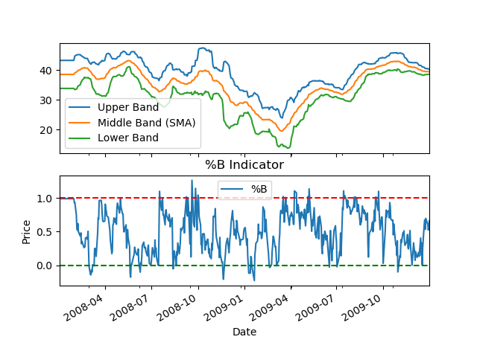

*Figure 3— This graph shows the Bollinger Bands (BB) and %B Indicator (%B) derived from JPM’s price movements.*

**2.4 Percentage Price Oscillator (PPO)**

The Percentage Price Oscillator (PPO) is a technical indicator used to measure and represent the difference between two EMAs as a percentage. In order to calculate PPO, we take the difference between the long-term 26-day and short-term 12-day EMAs and divide it by the 26-day EMA, then multiply that result by 100. The formula: **PPO = ((12-day EMA - 26-day EMA) / 26-day EMA) x 100**. The 9-day EMA of the PPO is used to calculate the signal line and finally, the difference between the PPO and the signal line is plotted as a histogram: **PPO Histogram: PPO – Signal Line.**

PPO is a momentum oscillator that oscillates above and below the zero, or center, line, which is where the 12-day EMA and the 26-day EMA are equal. When PPO is above zero, it indicates that the short-term EMA is higher than the long-term EMA, while a PPO value below zero indicates that the short-term EMA is lower than the long-term EMA. These are considered bullish and bearish signal movements respectively. PPO can also be used with other indicators such as the MACD and RSI to confirm signals or identify deviations.

Figure 4 shows an example of how the normalized JPM prices, short-term 12-day, and long-term 26-day EMAs behave in relation to the PPO histogram, represented as a line. The figure shows that the histogram values oscillate above and below the zero line, generating buy and sell signals.

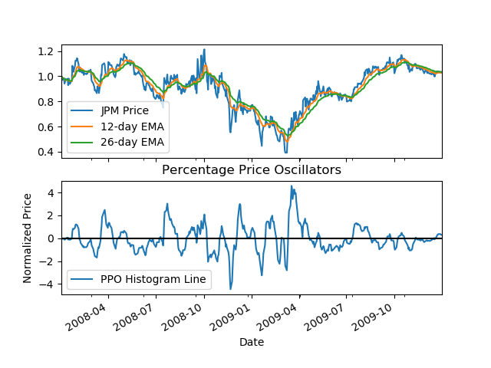

*Figure 4—This sub-graph shows the Percentage Price Oscillator (PPO) indicator results based on the 12-day and 26-day EMA values of JPM’s price movements as well as the PPO histogram.*

**2.5 Moving Average Convergence/Divergence Oscillator (MCDA)**

The Moving Average Convergence/Divergence (MACD) is a technical indicator that helps traders follow trends and momentum shifts, triggering potential buy or sell signals. MACD is made up of three line indicators: MACD line, signal line, and MACD histogram.

Similar to PPO, MACD utilizes 12-day and 26-day EMAs to calculate the MACD line, by subtracting the 26-day EMA from the 12-day EMA: **MACD Line: 12-day EMA – 26-day EMA**. The 9-day EMA of the MACD line is used to calculate the signal line and finally, the difference between the MACD line and the signal line is plotted as a histogram: **MACD Histogram: MACD Line – Signal Line**.

MACD indicator is based on the belief that short-term EMAs react more quickly to price changes than long-term EMAs. When the MACD line crosses above the signal line, it is considered a bullish signal movement, while crossing below the signal line, it is considered a bearish signal movement. The MACD histogram provides additional information regarding the strength of the trend. Similar to PPO, when the histogram bars are above the zero line, it indicates that the trend is bullish, while below the zero line indicates a bearish trend. The MACD indicator can also be utilized with other technical indicators, to generate buy/sell signals. For example, a trader may use the MACD to confirm a trend identified by a 9-day and 14-day SMA crossover.

Figure 5 displays the MACD indicator, consisting of the MACD line, signal line, and MACD histogram, represented as a line. As you can see, when the MACD line crosses above the signal line, it generates a bullish signal, indicating upward momentum. The same applies when the MACD line crosses below the signal line, except this indicates a bearish downward trend instead.

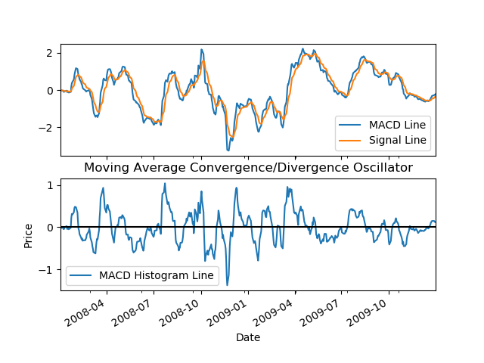

*Figure 5—The sub-graph shows the Moving Average Convergence/Divergence Oscillator indicator results based on the 12-day and 26-day EMA MACD line, 9-day EMA signal line, and MACD histogram.*

**3 THEORETICALLY OPTIMAL STRATEGY (TOS)**

Using the same time period and starting cash constraints as my indictors, the next component of this project was to implement an algorithm to maximize earnings during a specific timeframe. I was also given a set of rules to follow when conducting each trade. The allowable positions are 1000 shares long, 1000 shares short, and 0 shares. I’m able to trade up to 2000 shares at a time as long as my positions are 1000 shares long or 1000 shares short. This means that the only allowable portfolio holdings are: {-1000, 0, 1000}, and the only allowed trades I can make are: {-2000, -1000, 0, 1000, 2000}.

Theoretically Optimal Strategy (TOS) is a trading algorithm that aims to maximize profits by taking advantage of market inefficiencies. To create this algorithm, I assumed that the trader has access to historical price data for a given stock. I was then able to use this data to identify trends in price movements during the specified time period. Based on these trends, and set of rules, I was able to develop the algorithm to make optimal trading decisions.

The strategy assumes that stock prices prices are unpredictable and fluid. TOS also assumes that the trader has knowledge of the future price movements of a stock, which basically means they can look into the future. This assumption allows the algorithm to make optimal trading decisions on each trading day.

The TOS algorithm begins by executing a first trade, which is a buy or sell order that is executed at the beginning of the trading period. The first trade will always be 1000 shares, but will be +/- based on the order type, buy/sell. The starting net holdings amount will also equate to (+/-) 1000.

After the first trade is executed, the algorithm enters a loop that iterates over the remaining trading periods, expect for the last one. In each iteration, the algorithm checks the order type and the current holdings of the trader to determine which allowable trade, mentioned earlier, should be executed, or if no trade should occur at all during that trading period.

Once the TOS algorithm was implemented, the next task was to compare the portfolio values from my algorithm with benchmark portfolio values. Benchmark portfolio values are defined as the performance of a portfolio with the starting value of $100,000, investing in 1000 shares of JPM, and holding that position.

Figure 6 showcases the comparison of the normalized portfolio values for both the TOS algorithm and benchmark. As we can see, the TOS yields a higher price value as the timeframe progresses, which means I’m successfully achieving the project’s objective and maximizing earnings for each trade made. Using the same normalized portfolio values, Table 1 compares the cumulative return, standard deviation of daily returns, and mean of daily returns between the TOS algorithm and benchmark as well.

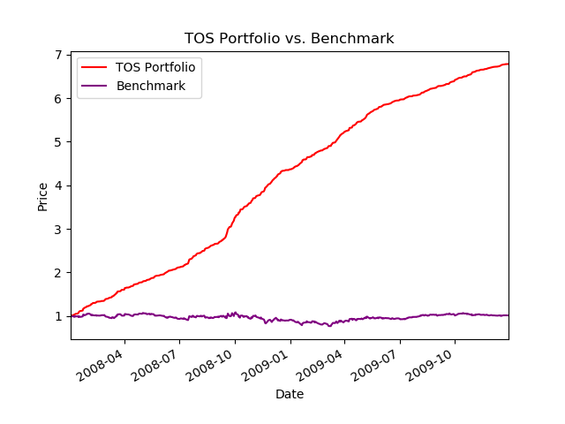

*Figure 6—This compares the portfolio values returned from the* *Theoretically Optimal Strategy and benchmark.*

|  |  |  |  |
| --- | --- | --- | --- |
| **Portfolio Type** | **Cumulative return** | **Standard Deviation** | **Mean** |
| Benchmark | 0.010600 | 0.017038 | 0.000165 |
| TOS | 5.7844 | 0.004551 | 0.003831 |

*Table 1—This compares the cumulative return, standard deviation, and mean calculations based off the portfolio values returned from the* *Theoretically Optimal Strategy and benchmark.*

**4 CONCLUSION**

In conclusion, the goal of this project was to develop a solid understanding of different trading indicators and how they can be implemented to generate trading signals. We also focused on the development of a theoretically optimal strategy, which represents the upper bounds or maximum amount that can be earned through trading given a specific instrument and timeframe. I hope readers have gained a strong foundation of knowledge in both of these areas throughout the course of this project.

**5 REFERENCES**

1. Chen, J. (2023, January 13). What is EMA? How to Use Exponential Moving Average With Formula. Investopedia. <https://www.investopedia.com/terms/e/ema.asp>
2. Dolan, B. (2022, December 19). MACD indicator explained, with formula, examples, and limitations. Investopedia. <https://www.investopedia.com/terms/m/macd.asp>
3. Hayes, A. (2023, January 11). Simple moving average (SMA): What it is and the formula. Investopedia. <https://www.investopedia.com/terms/s/sma.asp>
4. Mitchell, C. (2022, December 13). Percentage price oscillator (PPO): Definition and how it's used. Investopedia. <https://www.investopedia.com/terms/p/ppo.asp>
5. StockChart.com. (n.d.). %B indicator. %B Indicator [ChartSchool]. <https://school.stockcharts.com/doku.php?id=technical_indicators%3Abollinger_band_perce>
6. StockCharts.com. (n.d.). Bollinger bands. Bollinger Bands [ChartSchool]. <https://school.stockcharts.com/doku.php?id=technical_indicators%3Abollinger_bands>
7. StockCharts.com. (n.d.). MACD (moving average convergence/divergence oscillator). MACD (Moving Average Convergence/Divergence Oscillator) [ChartSchool]. <https://school.stockcharts.com/doku.php?id=technical_indicators%3Amoving_average_convergence_divergence_macd>
8. StockCharts.com. (n.d.). Moving averages - simple and exponential. Moving Averages - Simple and Exponential [ChartSchool]. <https://school.stockcharts.com/doku.php?id=technical_indicators%3Amoving_averages>
9. StockCharts.com. (n.d.). Percentage price oscillator. Percentage Price Oscillator [ChartSchool]. <https://school.stockcharts.com/doku.php?id=technical_indicators%3Aprice_oscillators_ppo>